***Conversational Chatbot using ML and NLP with Front End Framework***

A Conversational Chatbot is a peer-to-peer responsive agent. So, in this project we have used a combination of NLP and Deep Learning to train the agent to answers the questions asked by the user. The tools which we have used are TensorFlow to build the neural networks, nltk to process the text and numpy for manipulating the data and converting it to array, so that we can pass it to our neural network to process the information. Finally, we have integrated entire code with Tkinter GUI where we can have an interface type front end where we can interact with our agent.

**Note:** You can fully deploy this model to cloud, by training the model with more intents/questions.

***Base Paper***

1. <https://www.researchgate.net/publication/353694361_Conversational_AI_Chatbots>
2. <https://www.analyticsvidhya.com/blog/2021/07/build-a-simple-chatbot-using-python-and-nltk>

***Algorithm Description***

***TFlearn:*** TFlearn can be defined as flexible and transparent deep learning aspects which are used in TensorFlow framework and provides us a higher-level application programming interface. It boosts up the experiments which are performed during these tasks. It is very easy to use and easily understandable.

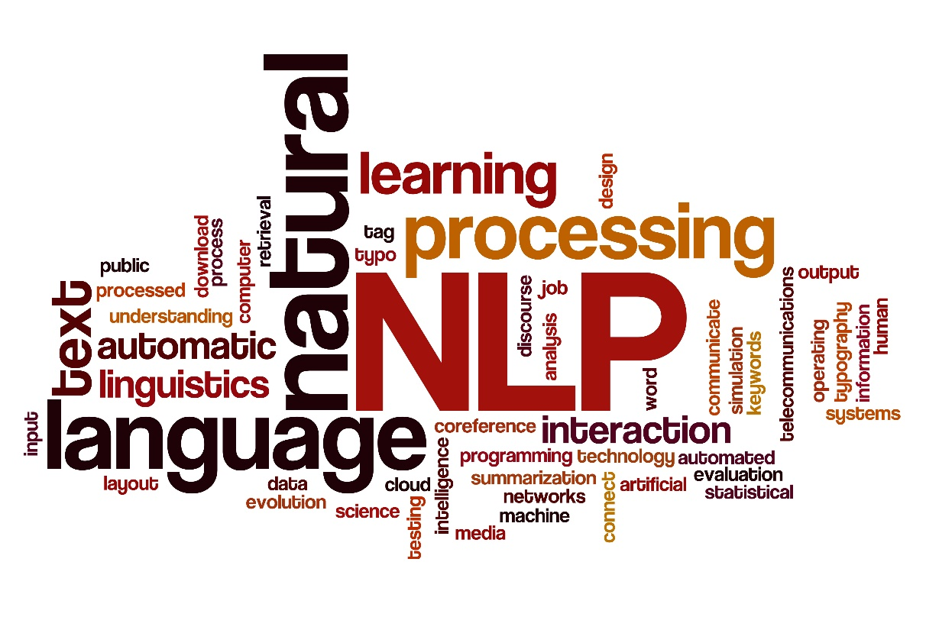

***References:***

1. <https://www.geeksforgeeks.org/tflearn-and-its-installation-in-tensorflow>

***Lancaster Stemmer:*** Lancaster Stemmer is the most assertive stemming algorithm. It has an edge over the stemming techniques because it offers us the functionality to add our own custom rules in this algorithm when we implement this using the NLTK package. Sometimes the results are unexpected.

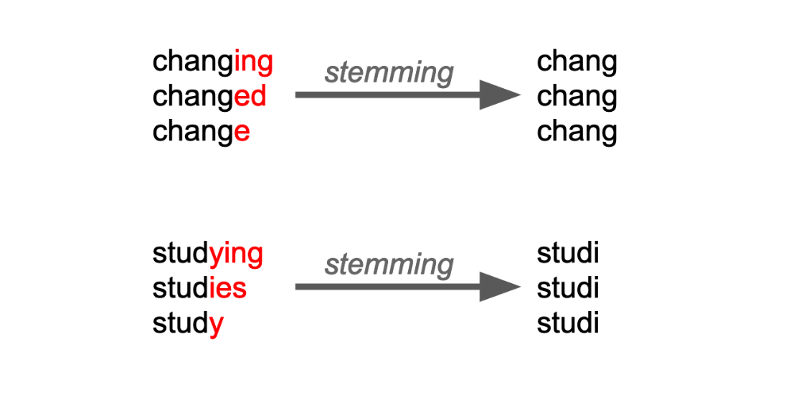

***References:***

1. <https://www.geeksforgeeks.org/introduction-to-stemming>

***Steps to Execute the Code!***

**Note:** Make sure you have added path while installing the software’s.

<https://techieyantechnologies.com/2022/07/how-to-install-anaconda/>

<https://techieyantechnologies.com/2022/06/get-started-with-creating-new-environment-in-anaconda-configuring-jupyter-notebook-and-installing-libraries-using-requirements-txt-2/>

1. Install the prerequisites/software’s required to execute the code from reading the above blog which is provided in the link above.
2. Press windows key and type in anaconda prompt a terminal opens up.
3. Go to the directory where your requirement.txt file is present, not just requirement.txt, if you want to execute any .py or .ipynb files, you need to go to that specific folder or path, where they are saved.

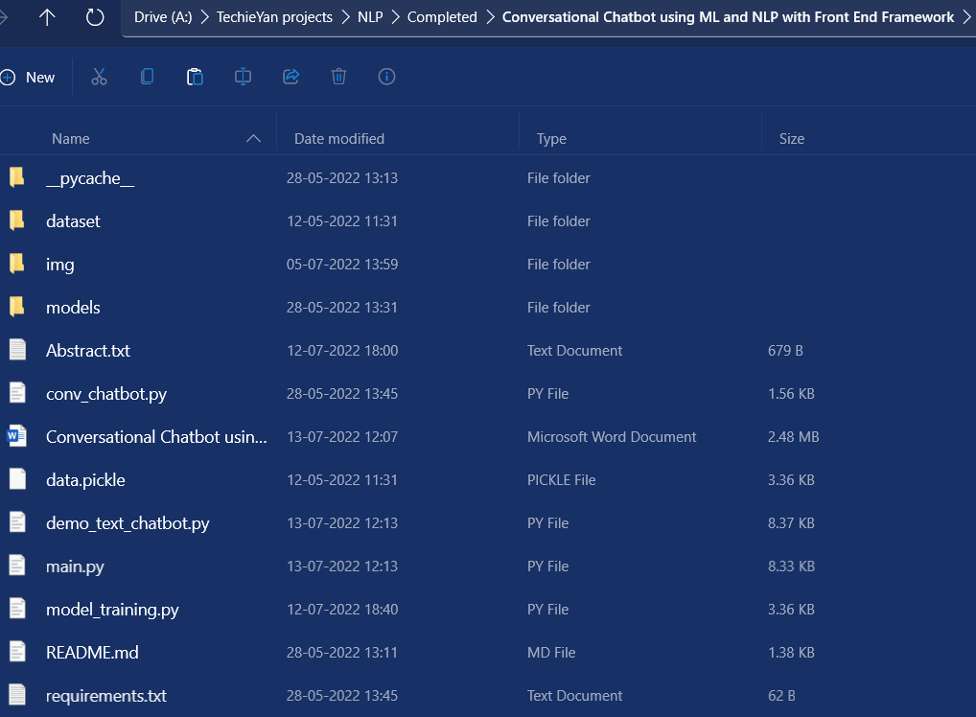

1. <<directory of your file:>>. E.g., If my file is in d drive, then
2. Type d:

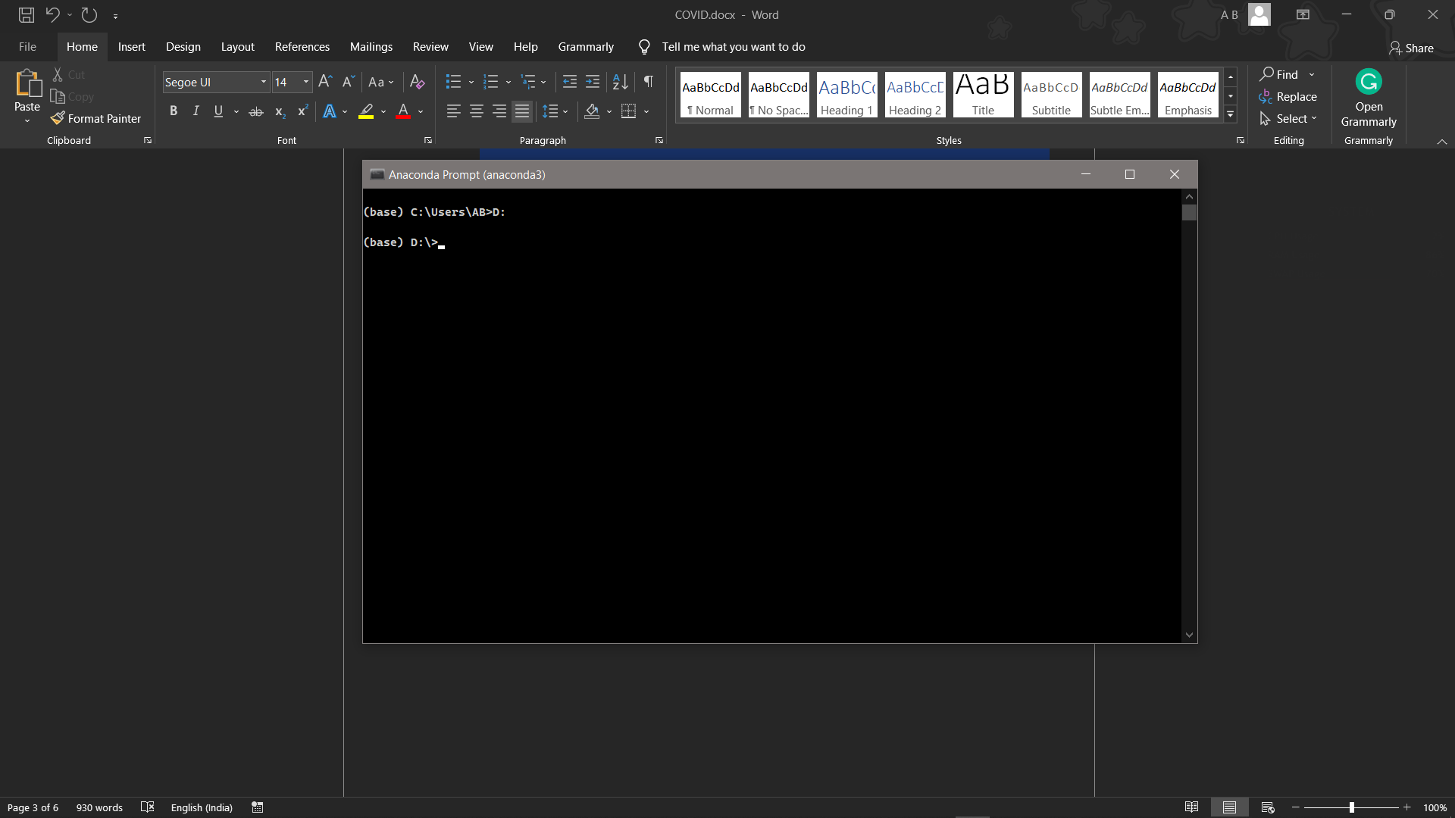

1. cd d:\License-Plate-Recognition-main #CHANGE PATH AS PER YOUR PROJECT, THIS IS JUST AN EXAMPLE

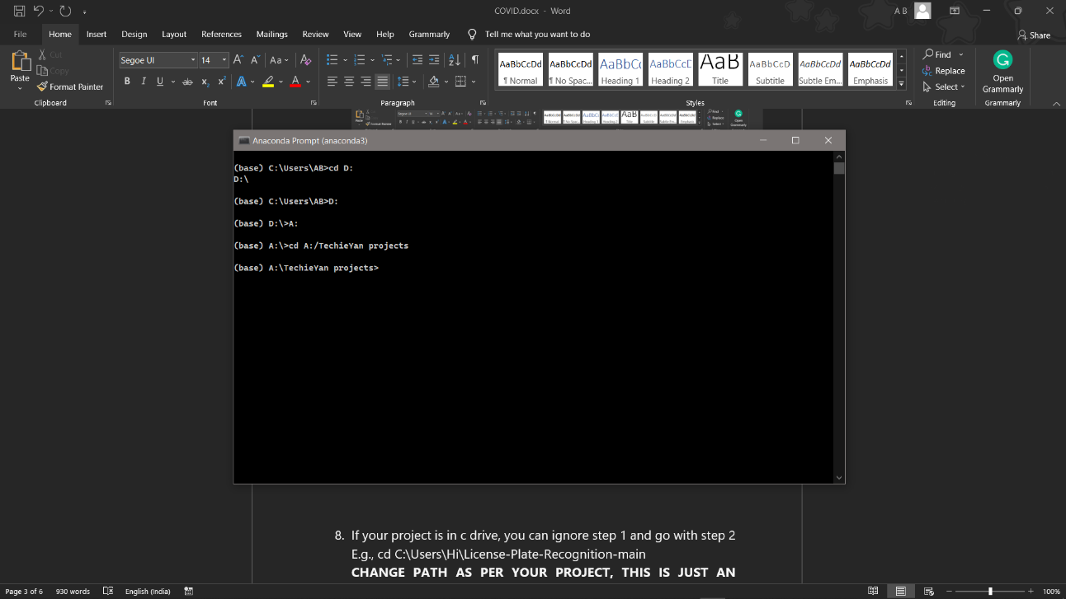

1. If your project is in c drive, you can ignore step 4 and go with step 5.

E.g., cd C:\Users\Hi\License-Plate-Recognition-main

**CHANGE PATH AS PER YOUR PROJECT, THIS IS JUST AN EXAMPLE**

1. Run pip install -r requirements.txt or conda install requirements.txt (Requirements.txt is a text file consisting of all the necessary libraries required for executing this python file. If it gives any error while installing libraries, you might need to install them individually.), example: pip install “module_name” i.e., pip install pandas

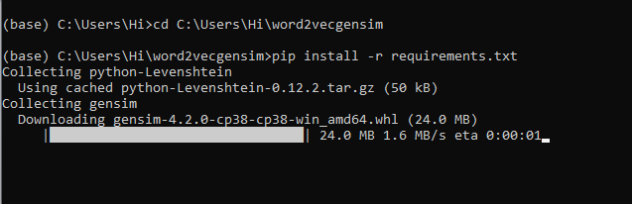

1. If you would like to run **main.py** file, please [follow the given link on how to setup anaconda prompt](https://techieyantechnologies.com/2022/07/how-to-install-anaconda/), and make sure to change the path where your executable file/folder is saved i.e follow 5,6,7 steps and type **python main.py**
2. Before directly running the **main.py** file make sure you have trained the model with the modified dataset, which you can find in the dataset folder.

* Train the model again to make the chatbot use to the added intents. After training the model, the model will be saved in the model’s folder.
* Now you can run python main.py to load and use the new model.

***Dataset Description***

Whenever we are trying to make a chatbot we need to make a list of intents which we wanted our chatbot to follow. The intents consist of **Tag, pattern, response and context set.** Where tag represents What is the other person trying to ask a chatbot, Example: Greeting, Identification, Goodbye, Food, Sports, Movies etc. Pattern represents what question the person is asking, Response represents the type of response the chatbot is willing to give. As this is a simple chatbot the responses are randomly picked from the list of responses for that particular question the person is asking.

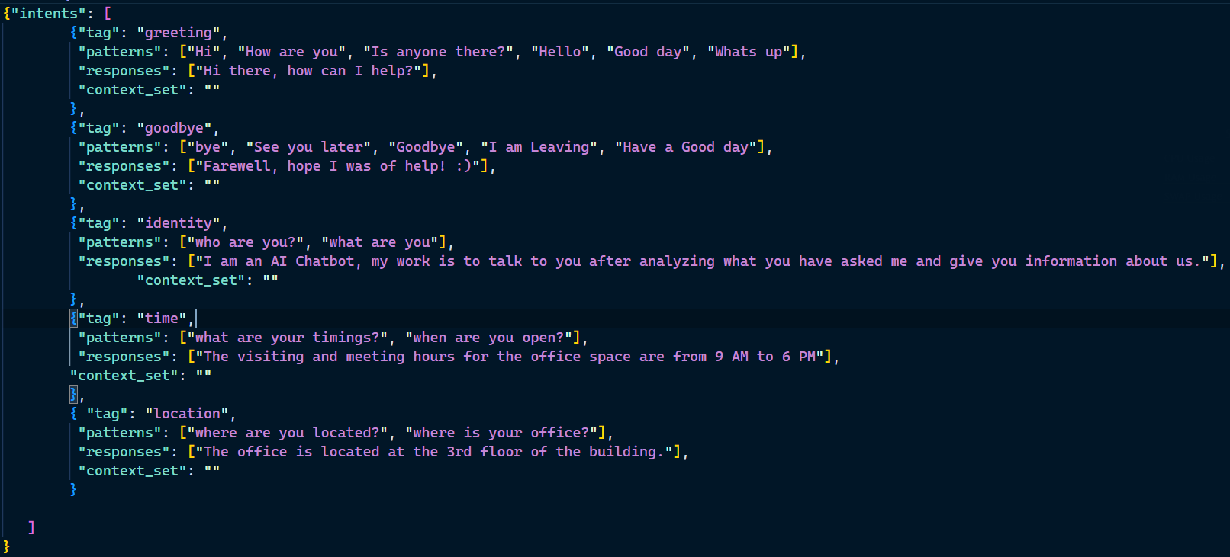

***Issues Faced***

1. We might face an issue while installing specific libraries, in this case, you might need to install the libraires manually. Example: pip install “module_name/library” i.e., pip install pandas

2. Make sure you have the latest or specific version of python, since sometimes it might cause version mismatch.

3. Adding path to environment variables in order to run python files and anaconda environment in code editor, specifically in any code editor.

4. Make sure to change the **paths in the code** accordingly where your dataset/model is saved.

**Refer to the Below links to get more details on installing python and anaconda and how to configure it.**

<https://techieyantechnologies.com/2022/07/how-to-install-anaconda/>

<https://techieyantechnologies.com/2022/06/get-started-with-creating-new-environment-in-anaconda-configuring-jupyter-notebook-and-installing-libraries-using-requirements-txt-2/>

***Note:***

**All the required data has been provided over here. Please feel free to contact me for model weights and if you face any issues.**

<https://www.linkedin.com/in/abhinay-lingala-5a3ab7205/>

***Yes, you now have more knowledge than yesterday, Keep Going.***

***Results***

